Superhero movies

Information acquired from IMDB for educational purposes only.

1. Infinity War (2018)

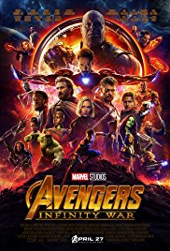

Description: The Avengers and their allies must be willing to sacrifice all in an attempt to defeat the powerful Thanos before his blitz of devastation and ruin puts an end to the universe.

Actors: Robert Downey Jr., Chris Hemsworth, Mark Ruffalo

Genre/type: Action, Adventure, Fantasy

PG-13

Ratings: 8.8/10 IMDB

1. Deadpool 2 (2018)



Description: Foul-mouthed mutant mercenary Wade Wilson (AKA. Deadpool), brings together a team of fellow mutant rogues to protect a young boy with supernatural abilities from the brutal, time-traveling cyborg, Cable.

Actors: Ryan Reynolds, Josh Brolin, Morena Baccarin, Julian Dennison

Genre/type: Action, Adventure, Comedy

R

Ratings: 8.1/10 IMBD

1. Black Panther (2017)

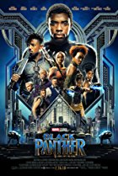

Description: T'Challa, the King of Wakanda, rises to the throne in the isolated, technologically advanced African nation, but his claim is challenged by a vengeful outsider who was a childhood victim of T'Challa's father's mistake.

Actors: Chadwick Boseman, Michael B. Jordan, Lupita Nyong'o, Danai Gurira

Genre/type: Actions, Adventure, Sci-Fi

PG-13

Ratings: 7.5 IMBD

Comedy movies

1. Superbad (2007)

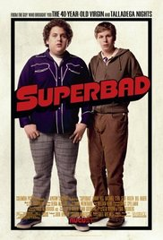

Two co-dependent high school seniors are forced to deal with separation anxiety after their plan to stage a booze-soaked party goes awry.

Stars: Michael Cera, Jonah Hill, Christopher Mintz-Plasse

Genre/type: Comedy

R

Ratings: 7.6 IMBD

1. Ocean’s 8 (2018)



Debbie Ocean gathers an all-female crew to attempt an impossible heist at New York City's yearly Met Gala.

Stars: Sandra Bullock, Cate Blanchett, Anne Hathaway

Genre/type: Action, Comedy, thriller

PG-13

Ratings: 6.2 IMBD

1. Jumanji: Welcome to the Jungle (2017)



Four teenagers are sucked into a magical video game, and the only way they can escape is to work together to finish the game.

Stars: Dwayne Johnson, Karen Gillan, Kevin Hart

Genre/type: adventure, comedy

PG-13

Ratings: 7.0 IMBD

Horror movies

1. Hereditary 2018



When the matriarch of the Graham family passes away, her daughter's family begins to unravel cryptic and increasingly terrifying secrets about their ancestry.

Stars: Toni Collette, Milly Shapiro, Gabriel Byrne

Genre/type: Drama, Horror, mystery

R

Ratings: 8.1/10 IMBD

1. IT (2017)

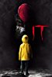

In the summer of 1989, a group of bullied kids band together to destroy a shapeshifting monster, which disguises itself as a clown and preys on the children of Derry, their small Maine town.

Stars: Bill Skarsgård, Jaeden Lieberher, Finn Wolfhard, Sophia Lillis

Genre/type: Drama, Horror, Thriller

R

Rating: 7.5 IMBD

1. A Quiet Place (2018)

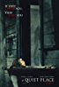

In a post-apocalyptic world, a family is forced to live in silence while hiding from monsters with ultra-sensitive hearing.

Stars: Emily Blunt, John Krasinski, Millicent Simmonds, Noah Jupe

Genre/type: Drama, Horror, Sci-Fi

PG-13

Ratings: 7.9 IMBD

Biographical Films

1. The Wolf of Wall Street (2013)

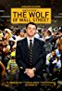

Based on the true story of Jordan Belfort, from his rise to a wealthy stock-broker living the high life to his fall involving crime, corruption and the federal government.

Stars: Leonardo DiCaprio, Jonah Hill, Margot Robbie, Matthew McConaughey

Genre/type: Biography, Comedy, Crime

R

Ratings: 8.2 IMBD

1. The King’s Speech (2010)

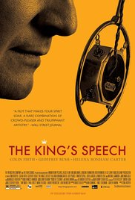

The story of King George VI of the United Kingdom of Great Britain and Northern Ireland, his impromptu ascension to the throne and the speech therapist who helped the unsure monarch become worthy of it.

Stars: Colin Firth, Geoffrey Rush, Helena Bonham Carter

Genre/type: Biography, Drama, History

R

Ratings: 8.0 IMBD

1. The Greatest Showman (2017)

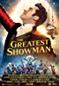

Celebrates the birth of show business, and tells of a visionary who rose from nothing to create a spectacle that became a worldwide sensation.

Stars: Hugh Jackman, Michelle Williams, Zac Efron

Genre/type: Biography, Music, Drama

PG

Ratings: 7.7 IMBD